A77-AM,S-Peru-Moche-Belt-Copper-100 BCE-400 CE

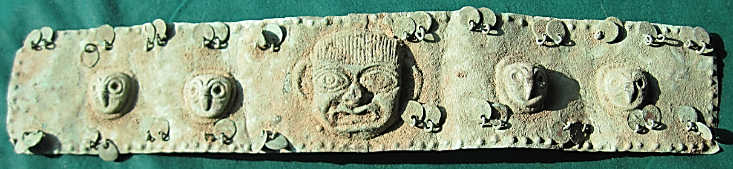

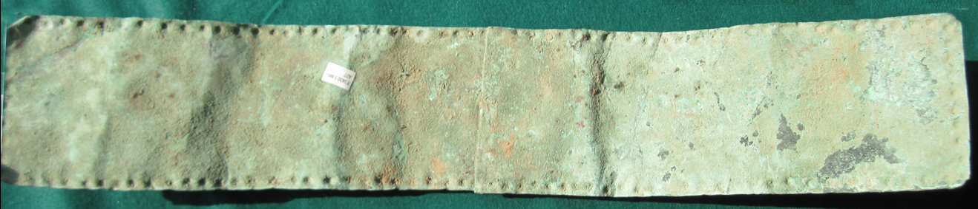

Figs. 1-2. Peru-Moche-Belt-Copper-100 BCE-400 CE

**Case no.: 7**

**Accession Number: A77**

**Formal Label:** Peru-Moche-Belt-Copper-100 BCE-400 CE

Display Description: Moche funerary copper belt with an apotropaic maskette in the center framed by two owl heads on either side from the N Coast of Peru dating to the Mochica II Period, 100 BC / 400 AD. The gilded image of the “Old Lord of Sipan” has a similar belt and the buried remains in the sarcophagus has a similar copper belt..

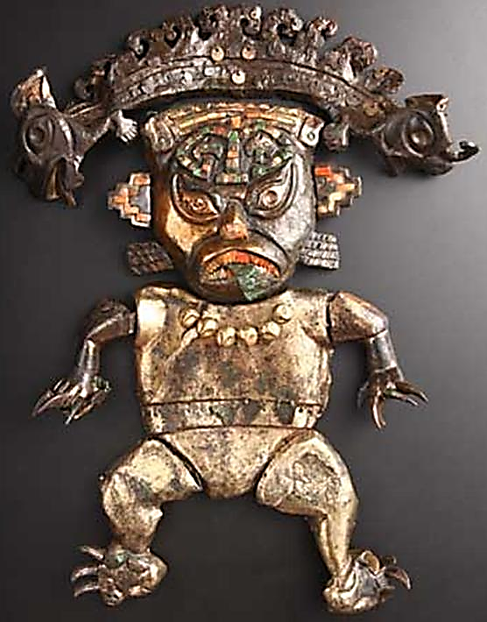 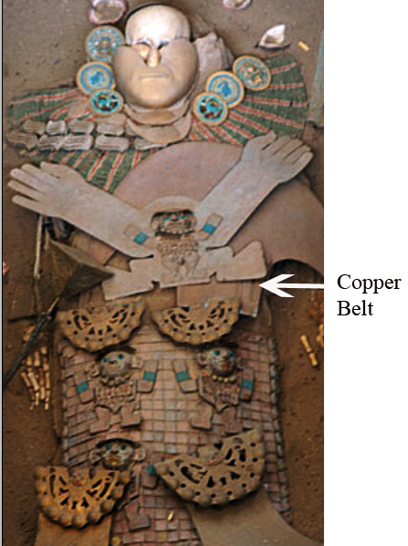

Fig. 3. The so-called “Old Lord of Sipan,” which is actually an apotropaic figure protecting the sarcophagus, wears a gilded belt. From Inca the Exhibition in Seoul, Korea, <http://el-libertario.webnode.es/arte-significativo>. The “Lord of Sipan” was an important Mochican warrior-priest, whose remains were interred in Huaca Rajada and excavated by Dr. Walter Alva in 1987. Fig. 4. In a carved wooden sarcophagus the “Old Lord of Sipan” wears a copper belt like the present example indicating his high-ranking status. From http://www.go2peru.com/peru_guide/chiclayo/archaeological_places.htm#huaca_rajada.

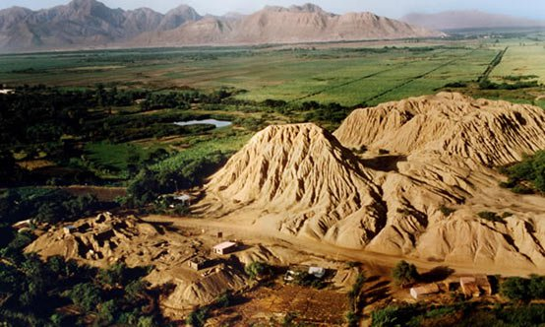 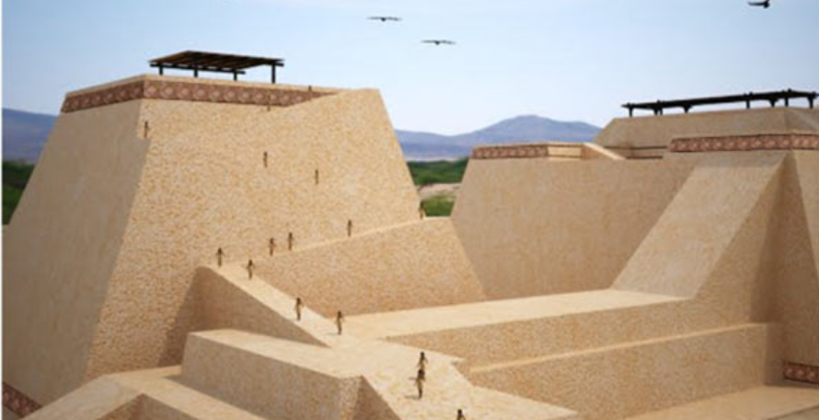

Fig. 5. Huaca Rajada mound complex. [http://www.ancient-origins.net/sites/default/files/Huaca-Rajada-tomb-complex-Sipan.jpg. Fig](http://www.ancient-origins.net/sites/default/files/Huaca-Rajada-tomb-complex-Sipan.jpg.%20Fig). 6. Huaca Rajada reconstructed. From http://www.ancient-origins.net/sites/default/files/field/image/Mochican-tomb-complex-of-Huaca-Rajada-Peru.jpg

**LC Classification: F3430.1.**

**Date or Time Horizon:** 100 BCE-400 CE

**Geographical Area:** N coastal Peru

**Map, GPS coordinates: -6.80139 -79.60202; 6º48'5" S 79º36'7.28" W.**

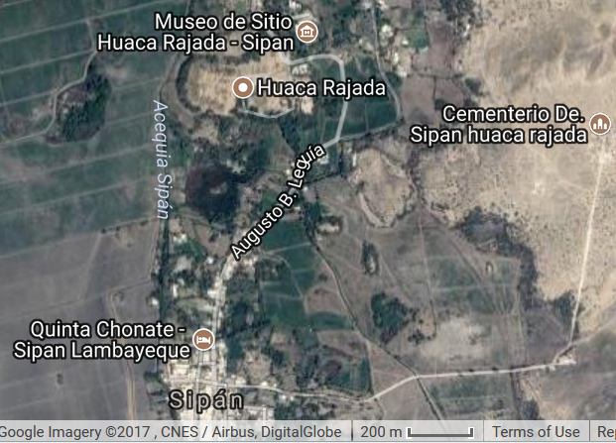

**Cultural Affiliation:** Moche, Mochica

**Medium:** copper

**Dimensions:** L 548.56 mm; 21.596 in

**Weight: 376 gm; 13 7/8 oz**

**Condition: original**

**Provenance:** old Peruvian collection

**Discussion:**

**References:**